**cv. 08 – Policing a shaping**

**Kováč, Kurnas**

3 toky s rôznym rozdelením podľa zadania bez akýchkoľvek politík:

a.) s rovnomerným rozdelením = uniform od 100 do 500 B

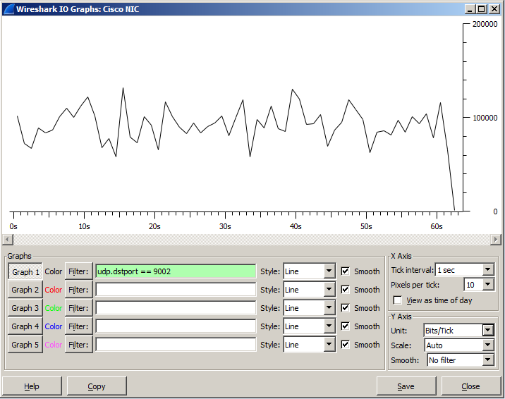

b.) s exponenciálnym rozdelením so strednou veľkosťou paketu 300 B

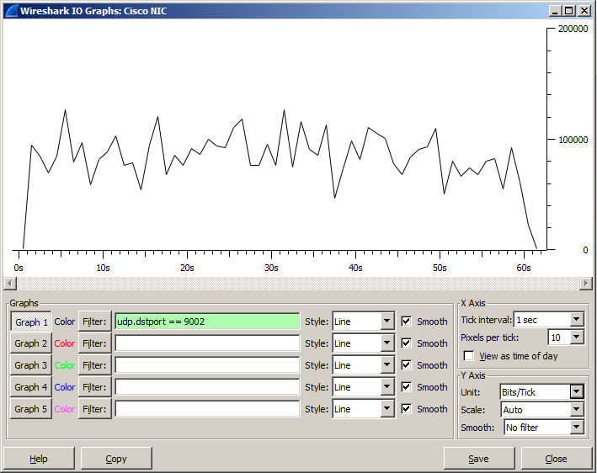

c.) s exp. rozdelením so strednou dĺžkou 400 B

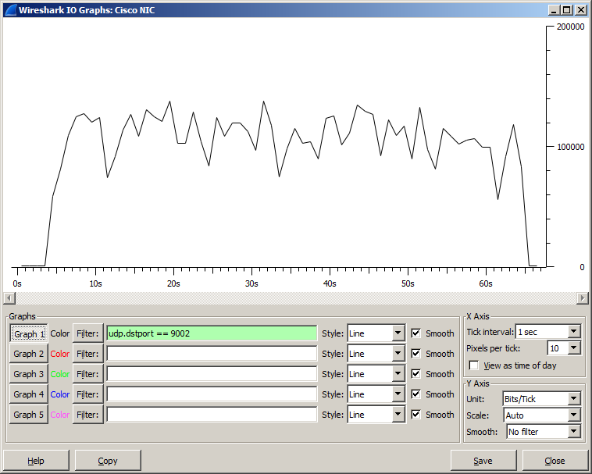

**Policing and shaping**

Toky: Tri UDP toky s 84 kb/s

Intenzita: 35 pak/s - náhodné časy príchodov s expon. rozdelením, pričom priemerne bude chodiť 35

**Scenáre pre experimenty s policingom:**

**Scenár 1. Single rate two color (jednoduchý token bucket)**

A. Obmedzovať prevádzku (policing) pre špecifickú triedu. Obmedzovať budeme čo najbližšie k zdroju, takže na vstupnom porte R1 z danej LAN:

**a.) s rovnomerným rozdelením = uniform od 100 do 500 B**

Výpis z R1:

R1#sh policy-map int f0/0

FastEthernet0/0

Service-policy input: POLICING_DROP

Class-map: ZAKAZNIK (match-all)

2091 packets, 715495 bytes

5 minute offered rate 13000 bps, drop rate 0000 bps

Match: access-group 101

QoS Set

dscp 2

Packets marked 2091

police:

cir 84000 bps, bc 2625 bytes

conformed 1877 packets, 628489 bytes; actions:

transmit

exceeded 214 packets, 87006 bytes; actions:

drop

conformed 12000 bps, exceeded 0000 bps

Class-map: class-default (match-any)

9 packets, 567 bytes

5 minute offered rate 0000 bps, drop rate 0000 bps

Match: any

Bc = veľkosť vedra = max. počet tokenov vo vedre je 21000 bitov.

Tc = Bc/ CIR

Interval dopĺňaní je 0.25 za sekundu.

1/Tc

Vedro tokenov sa dopĺňa 4 krát za sekundu.

**Graf:**

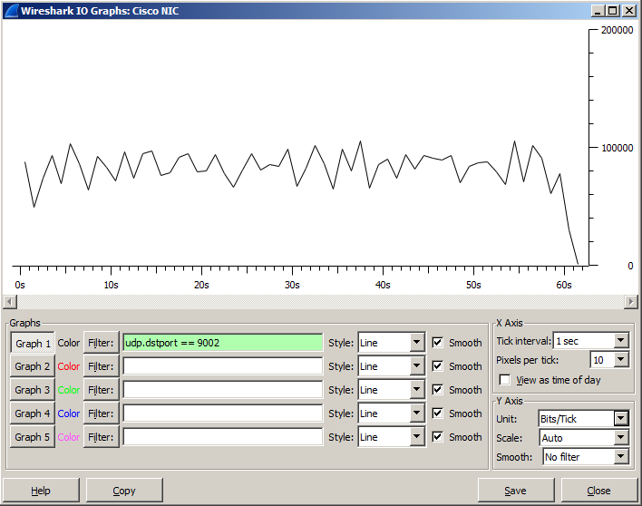

**Výpis z D-ITG:**

__________________________________________________________

**************** TOTAL RESULTS ******************

__________________________________________________________

Number of flows = 1

Total time = 60.135000 s

Total packets = 1877

Minimum delay = 343.644000 s

Maximum delay = 344.117000 s

Average delay = 343.847298 s

Average jitter = 0.012285 s

Delay standard deviation = 0.083768 s

Bytes received = 549655

Average bitrate = 73.122807 Kbit/s

Average packet rate = 31.213104 pkt/s

Packets dropped = 214 (10.23 %)

Average loss-burst size = 1.417219 pkt

Error lines = 0

----------------------------------------------------------

**b.) s exponenciálnym rozdelením so strednou veľkosťou paketu 300 B**

R1#sh policy-map int f0/0

FastEthernet0/0

Service-policy input: POLICING_DROP

Class-map: ZAKAZNIK (match-all)

4180 packets, 1427233 bytes

5 minute offered rate 18000 bps, drop rate 5000 bps

Match: access-group 101

QoS Set

dscp 2

Packets marked 4180

police:

cir 84000 bps, bc 2625 bytes

conformed 3830 packets, 1232087 bytes; actions:

transmit

exceeded 350 packets, 195146 bytes; actions:

drop

conformed 17000 bps, exceeded 5000 bps

Class-map: class-default (match-any)

18 packets, 1134 bytes

5 minute offered rate 0000 bps, drop rate 0000 bps

Match: any

**Graf:**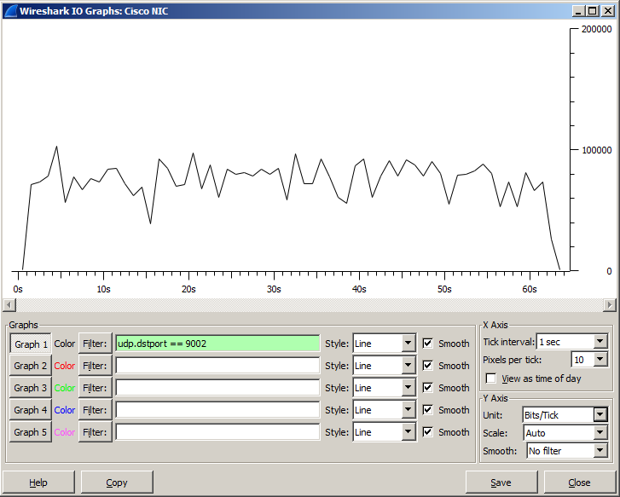

**Výpis z D-ITG:**

__________________________________________________________

**************** TOTAL RESULTS ******************

__________________________________________________________

Number of flows = 1

Total time = 61.133000 s

Total packets = 1934

Minimum delay = 343.970000 s

Maximum delay = 345.183000 s

Average delay = 344.612607 s

Average jitter = 0.016864 s

Delay standard deviation = 0.368073 s

Bytes received = 518038

Average bitrate = 67.791602 Kbit/s

Average packet rate = 31.635941 pkt/s

Packets dropped = 133 (6.43 %)

Average loss-burst size = 1.209091 pkt

Error lines = 0

----------------------------------------------------------

**c.) s exp. rozdelením so strednou dĺžkou 400 B**

R1#sh policy-map int f0/0

FastEthernet0/0

Service-policy input: POLICING_DROP

Class-map: ZAKAZNIK (match-all)

6323 packets, 2337030 bytes

5 minute offered rate 2000 bps, drop rate 0000 bps

Match: access-group 101

QoS Set

dscp 2

Packets marked 6323

police:

cir 84000 bps, bc 2625 bytes

conformed 5665 packets, 1876499 bytes; actions:

transmit

exceeded 658 packets, 460531 bytes; actions:

drop

conformed 0000 bps, exceeded 0000 bps

Class-map: class-default (match-any)

27 packets, 1701 bytes

5 minute offered rate 0000 bps, drop rate 0000 bps

Match: any

**Graf:**

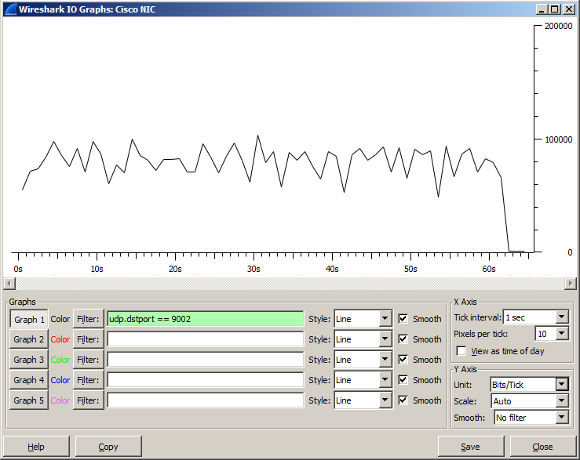

**Výpis z D-ITG:**

__________________________________________________________

**************** TOTAL RESULTS ******************

__________________________________________________________

Number of flows = 1

Total time = 61.901000 s

Total packets = 1800

Minimum delay = 344.022000 s

Maximum delay = 345.998000 s

Average delay = 345.139618 s

Average jitter = 0.018962 s

Delay standard deviation = 0.518256 s

Bytes received = 551349

Average bitrate = 71.255586 Kbit/s

Average packet rate = 29.078690 pkt/s

Packets dropped = 300 (14.29 %)

Average loss-burst size = 1.304348 pkt

Error lines = 0

B. Teraz pakety presahujúce limit nezahadzujte, ale označkujte ich DSCP značkou af12, aby sme ich videli v IO graphs vo Wiresharku.

**a.) s rovnomerným rozdelením = uniform od 100 do 500 B**

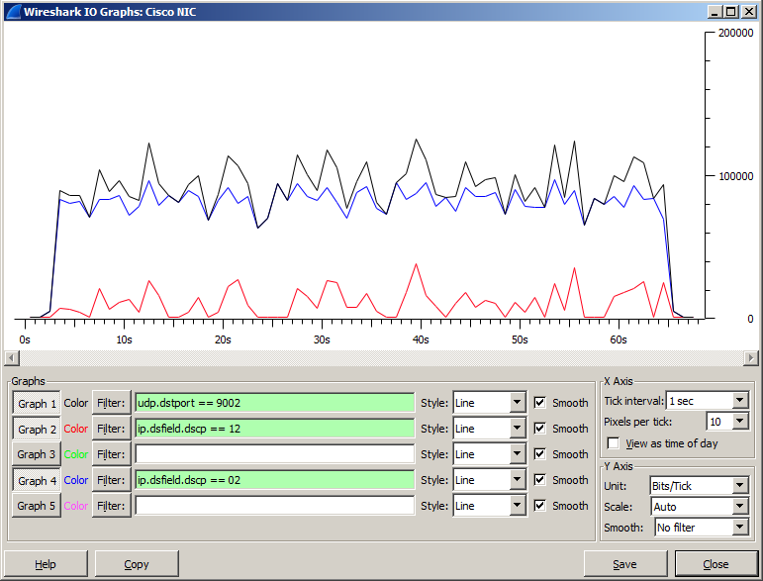

**Výpis z D-ITG:**

__________________________________________________________

**************** TOTAL RESULTS ******************

__________________________________________________________

Number of flows = 1

Total time = 62.060000 s

Total packets = 2104

Minimum delay = 325.350000 s

Maximum delay = 327.666000 s

Average delay = 326.403740 s

Average jitter = 0.014018 s

Delay standard deviation = 0.657581 s

Bytes received = 630207

Average bitrate = 81.238414 Kbit/s

Average packet rate = 33.902675 pkt/s

Packets dropped = 0 (0.00 %)

Average loss-burst size = 0 pkt

Error lines = 0

----------------------------------------------------------

**b.) s exponenciálnym rozdelením so strednou veľkosťou paketu 300 B**

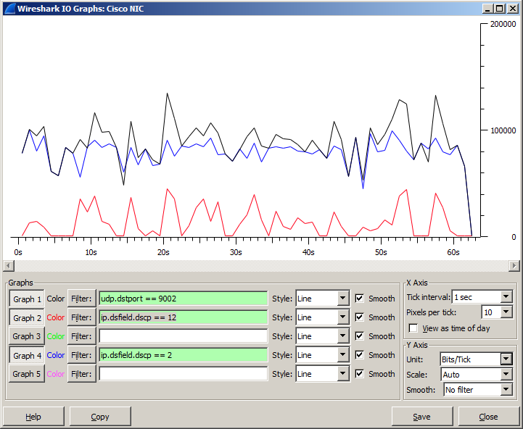

**Výpis z D-ITG:**

__________________________________________________________

**************** TOTAL RESULTS ******************

__________________________________________________________

Number of flows = 1

Total time = 61.578000 s

Total packets = 2072

Minimum delay = 345.230000 s

Maximum delay = 347.140000 s

Average delay = 346.170444 s

Average jitter = 0.019576 s

Delay standard deviation = 0.504435 s

Bytes received = 627942

Average bitrate = 81.580045 Kbit/s

Average packet rate = 33.648381 pkt/s

Packets dropped = 0 (0.00 %)

Average loss-burst size = 0 pkt

Error lines = 0

----------------------------------------------------------

**c.) s exp. rozdelením so strednou dĺžkou 400 B**

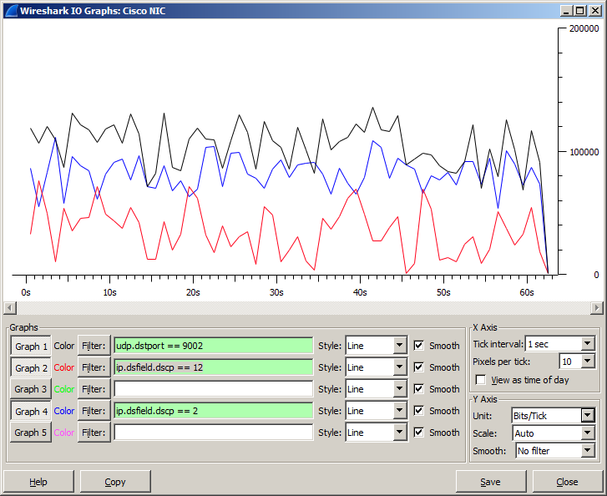

**Výpis z D-ITG:**

__________________________________________________________

**************** TOTAL RESULTS ******************

__________________________________________________________

Number of flows = 1

Total time = 61.571000 s

Total packets = 2029

Minimum delay = 343.980000 s

Maximum delay = 345.886000 s

Average delay = 344.906224 s

Average jitter = 0.025643 s

Delay standard deviation = 0.462590 s

Bytes received = 817600

Average bitrate = 106.231830 Kbit/s

Average packet rate = 32.953826 pkt/s

Packets dropped = 0 (0.00 %)

Average loss-burst size = 0 pkt

Error lines = 0

----------------------------------------------------------

**Scenár 2. Single Rate Three Color Marker (srTCM)**

Pritekajúce tokeny, ktoré sa nezmestia do prvého vedra, ktorého veľkosť je Bc = conform burst, sa budú ukladať do druhého vedra veľkosti Be = excess burst.

**a.) s rovnomerným rozdelením = uniform od 100 do 500 B**

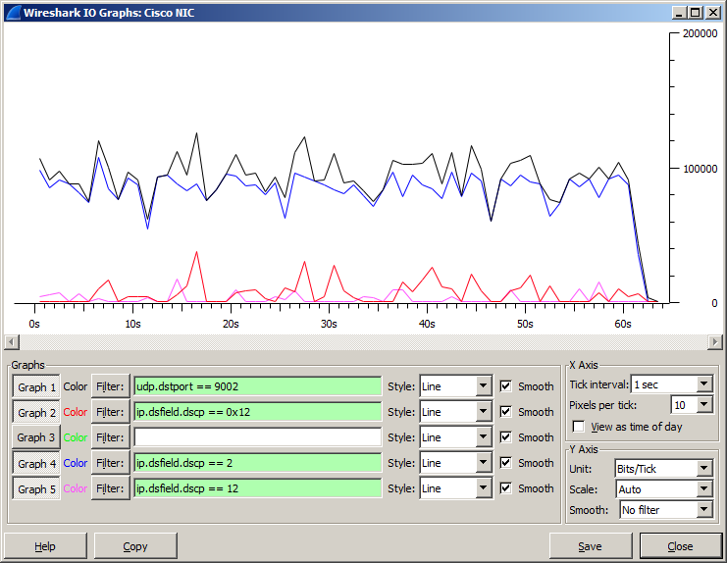

**Výpis z D-ITG:**

__________________________________________________________

**************** TOTAL RESULTS ******************

__________________________________________________________

Number of flows = 1

Total time = 61.390000 s

Total packets = 2098

Minimum delay = 376.093000 s

Maximum delay = 377.660000 s

Average delay = 376.906947 s

Average jitter = 0.014063 s

Delay standard deviation = 0.454154 s

Bytes received = 633054

Average bitrate = 82.496042 Kbit/s

Average packet rate = 34.174947 pkt/s

Packets dropped = 0 (0.00 %)

Average loss-burst size = 0 pkt

Error lines = 0

----------------------------------------------------------

**Výpis sendera:**

R1#sh policy-map int f0/0

FastEthernet0/0

Service-policy input: POLICING2_srTCM

Class-map: ZAKAZNIK (match-all)

4126 packets, 1404232 bytes

5 minute offered rate 2000 bps, drop rate 0000 bps

Match: access-group 101

QoS Set

dscp 2

Packets marked 4126

police:

cir 84000 bps, bc 3000 bytes, be 3000 bytes

conformed 3856 packets, 1291714 bytes; actions:

transmit

exceeded 93 packets, 38818 bytes; actions:

set-dscp-transmit af12

violated 177 packets, 73700 bytes; actions:

set-dscp-transmit af21

conformed 2000 bps, exceeded 0000 bps, violated 0000 bps

Class-map: class-default (match-any)

18 packets, 1134 bytes

5 minute offered rate 0000 bps, drop rate 0000 bps

Match: any

**b.) s exponenciálnym rozdelením so strednou veľkosťou paketu 300 B**

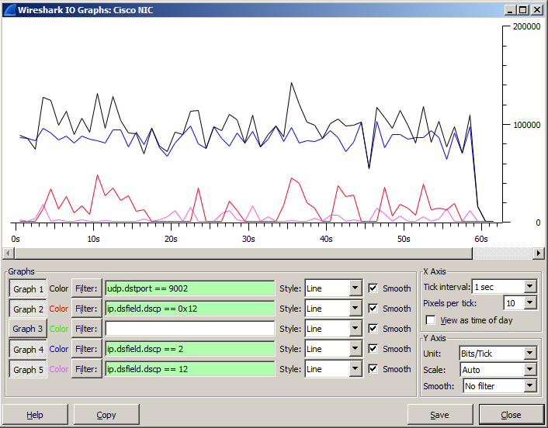

**Výpis z D-ITG:**

__________________________________________________________

**************** TOTAL RESULTS ******************

__________________________________________________________

Number of flows = 1

Total time = 59.122000 s

Total packets = 2156

Minimum delay = 343.057000 s

Maximum delay = 344.106000 s

Average delay = 343.541500 s

Average jitter = 0.019627 s

Delay standard deviation = 0.310874 s

Bytes received = 654758

Average bitrate = 88.597544 Kbit/s

Average packet rate = 36.466967 pkt/s

Packets dropped = 0 (0.00 %)

Average loss-burst size = 0 pkt

Error lines = 0

----------------------------------------------------------

**Výpis sendera:**

R1#sh policy-map int f0/0

FastEthernet0/0

Service-policy input: POLICING2_srTCM

Class-map: ZAKAZNIK (match-all)

6300 packets, 2150401 bytes

5 minute offered rate 14000 bps, drop rate 0000 bps

Match: access-group 101

QoS Set

dscp 2

Packets marked 6300

police:

cir 84000 bps, bc 3000 bytes, be 3000 bytes

conformed 5864 packets, 1919033 bytes; actions:

transmit

exceeded 143 packets, 62274 bytes; actions:

set-dscp-transmit af12

violated 293 packets, 169094 bytes; actions:

set-dscp-transmit af21

conformed 12000 bps, exceeded 0000 bps, violated 0000 bps

Class-map: class-default (match-any)

27 packets, 1701 bytes

5 minute offered rate 0000 bps, drop rate 0000 bps

Match: any

**c.) s exp. rozdelením so strednou dĺžkou 400 B**

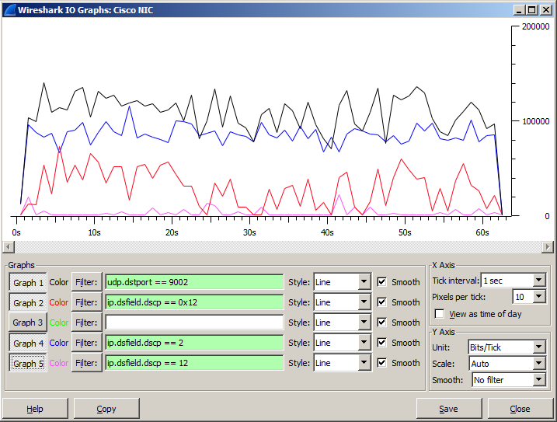

**Výpis z D-ITG:**

__________________________________________________________

**************** TOTAL RESULTS ******************

__________________________________________________________

Number of flows = 1

Total time = 61.017000 s

Total packets = 2079

Minimum delay = 343.607000 s

Maximum delay = 345.060000 s

Average delay = 344.190708 s

Average jitter = 0.024981 s

Delay standard deviation = 0.352177 s

Bytes received = 809956

Average bitrate = 106.194143 Kbit/s

Average packet rate = 34.072472 pkt/s

Packets dropped = 0 (0.00 %)

Average loss-burst size = 0 pkt

Error lines = 0

----------------------------------------------------------

**Výpis sendera:**

R1#sh policy-map int f0/0

FastEthernet0/0

Service-policy input: POLICING2_srTCM

Class-map: ZAKAZNIK (match-all)

8422 packets, 3049351 bytes

5 minute offered rate 21000 bps, drop rate 0000 bps

Match: access-group 101

QoS Set

dscp 2

Packets marked 8422

police:

cir 84000 bps, bc 3000 bytes, be 3000 bytes

conformed 7675 packets, 2573689 bytes; actions:

transmit

exceeded 177 packets, 79980 bytes; actions:

set-dscp-transmit af12

violated 570 packets, 395682 bytes; actions:

set-dscp-transmit af21

conformed 15000 bps, exceeded 0000 bps, violated 2000 bps

Class-map: class-default (match-any)

36 packets, 2268 bytes

5 minute offered rate 0000 bps, drop rate 0000 bps

Match: any

**Scenár 3. Two Rate Three Color Marker (trTCM)**

**a.) s rovnomerným rozdelením = uniform od 100 do 500 B**

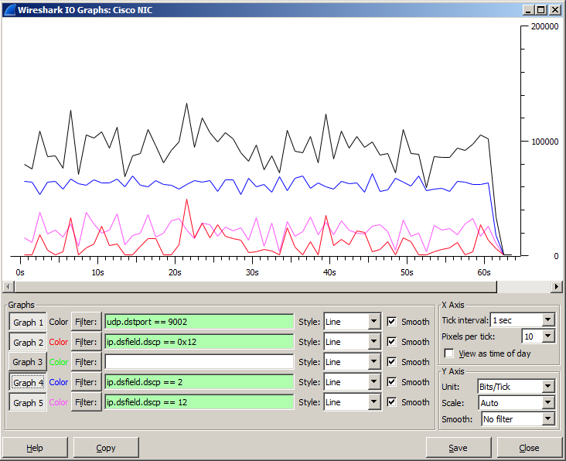

**Výpis z D-ITG:**

__________________________________________________________

**************** TOTAL RESULTS ******************

__________________________________________________________

Number of flows = 1

Total time = 61.186000 s

Total packets = 2092

Minimum delay = 343.906000 s

Maximum delay = 345.215000 s

Average delay = 344.373951 s

Average jitter = 0.014382 s

Delay standard deviation = 0.383831 s

Bytes received = 630733

Average bitrate = 82.467623 Kbit/s

Average packet rate = 34.190828 pkt/s

Packets dropped = 0 (0.00 %)

Average loss-burst size = 0 pkt

Error lines = 0

----------------------------------------------------------

**Výpis sendera:**

R1#sh policy-map int f0/0

FastEthernet0/0

Service-policy input: #POLICING3_trTCM

Class-map: ZAKAZNIK (match-all)

2092 packets, 718597 bytes

5 minute offered rate 12000 bps, drop rate 0000 bps

Match: access-group 101

QoS Set

dscp 2

Packets marked 2092

police:

cir 60000 bps, bc 1875 bytes

pir 84000 bps, be 2625 bytes

conformed 1486 packets, 473985 bytes; actions:

transmit

exceeded 412 packets, 166733 bytes; actions:

set-dscp-transmit af12

violated 194 packets, 77879 bytes; actions:

set-dscp-transmit af21

conformed 5000 bps, exceeded 0000 bps, violated 0000 bps

Class-map: class-default (match-any)

9 packets, 567 bytes

5 minute offered rate 0000 bps, drop rate 0000 bps

Match: any

**b.) s exponenciálnym rozdelením so strednou veľkosťou paketu 300 B**

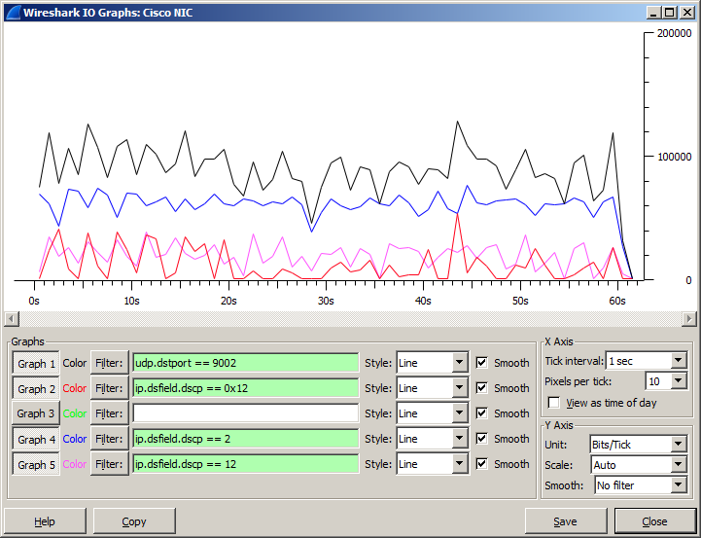

**Výpis z D-ITG:**

__________________________________________________________

**************** TOTAL RESULTS ******************

__________________________________________________________

Number of flows = 1

Total time = 60.268000 s

Total packets = 2078

Minimum delay = 343.184000 s

Maximum delay = 344.023000 s

Average delay = 343.595129 s

Average jitter = 0.018443 s

Delay standard deviation = 0.208866 s

Bytes received = 609170

Average bitrate = 80.861485 Kbit/s

Average packet rate = 34.479326 pkt/s

Packets dropped = 0 (0.00 %)

Average loss-burst size = 0 pkt

Error lines = 0

----------------------------------------------------------

**Výpis sendera:**

R1#sh policy-map int f0/0

FastEthernet0/0

Service-policy input: #POLICING3_trTCM

Class-map: ZAKAZNIK (match-all)

4181 packets, 1415670 bytes

5 minute offered rate 20000 bps, drop rate 0000 bps

Match: access-group 101

QoS Set

dscp 2

Packets marked 4181

police:

cir 60000 bps, bc 1875 bytes

pir 84000 bps, be 2625 bytes

conformed 3224 packets, 938291 bytes; actions:

transmit

exceeded 654 packets, 313220 bytes; actions:

set-dscp-transmit af12

violated 303 packets, 164159 bytes; actions:

set-dscp-transmit af21

conformed 14000 bps, exceeded 7000 bps, violated 5000 bps

Class-map: class-default (match-any)

18 packets, 1134 bytes

5 minute offered rate 0000 bps, drop rate 0000 bps

Match: any

**c.) s exp. rozdelením so strednou dĺžkou 400 B**

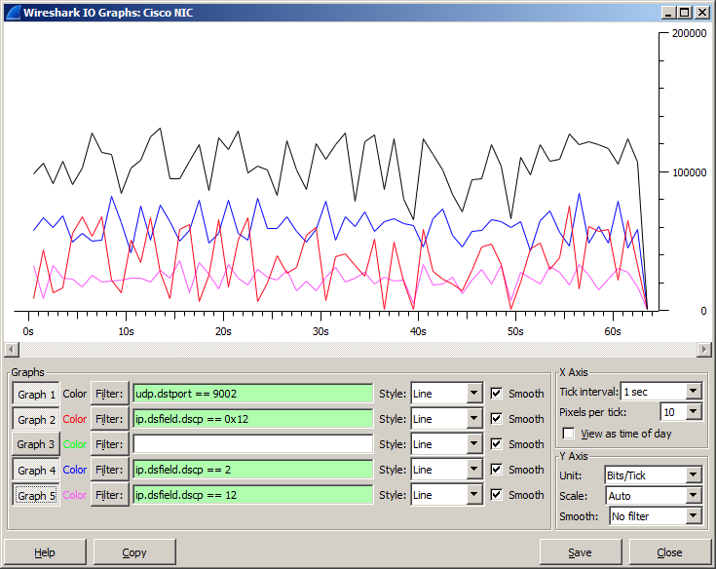

**Výpis z D-ITG:**

__________________________________________________________

**************** TOTAL RESULTS ******************

__________________________________________________________

Number of flows = 1

Total time = 62.725000 s

Total packets = 2099

Minimum delay = 343.695000 s

Maximum delay = 346.627000 s

Average delay = 344.926297 s

Average jitter = 0.025185 s

Delay standard deviation = 0.760714 s

Bytes received = 839787

Average bitrate = 107.107150 Kbit/s

Average packet rate = 33.463531 pkt/s

Packets dropped = 0 (0.00 %)

Average loss-burst size = 0 pkt

Error lines = 0

----------------------------------------------------------

**Výpis sendera:**

R1#sh policy-map int f0/0

FastEthernet0/0

Service-policy input: #POLICING3_trTCM

Class-map: ZAKAZNIK (match-all)

6345 packets, 2346063 bytes

5 minute offered rate 28000 bps, drop rate 0000 bps

Match: access-group 101

QoS Set

dscp 2

Packets marked 6345

police:

cir 60000 bps, bc 1875 bytes

pir 84000 bps, be 2625 bytes

conformed 4805 packets, 1411569 bytes; actions:

transmit

exceeded 912 packets, 490490 bytes; actions:

set-dscp-transmit af12

violated 628 packets, 444004 bytes; actions:

set-dscp-transmit af21

conformed 13000 bps, exceeded 5000 bps, violated 7000 bps

Class-map: class-default (match-any)

28 packets, 1761 bytes

5 minute offered rate 0000 bps, drop rate 0000 bps

Match: any

**SHAPING**

**Scenár 1. Nastavte tvarovanie prevádzky s ohľadom na priemer (shape average)**

**a.) s rovnomerným rozdelením = uniform od 100 do 500 B**

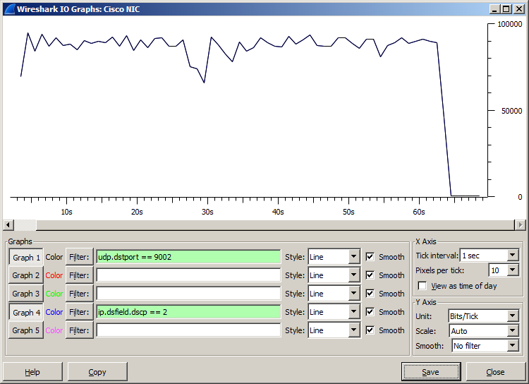

**Výpis z D-ITG:**

__________________________________________________________

**************** TOTAL RESULTS ******************

__________________________________________________________

Number of flows = 1

Total time = 61.339000 s

Total packets = 1970

Minimum delay = 343.960000 s

Maximum delay = 347.424000 s

Average delay = 345.708212 s

Average jitter = 0.023405 s

Delay standard deviation = 0.795042 s

Bytes received = 588576

Average bitrate = 76.763690 Kbit/s

Average packet rate = 32.116598 pkt/s

Packets dropped = 19 (0.96 %)

Average loss-burst size = 1.900000 pkt

Error lines = 0

----------------------------------------------------------

**Výpis sendera:**

R1#sh policy-map int s0/0/0

Serial0/0/0

Service-policy output: SHAPING_AVERAGE

Class-map: ZAKAZNIK (match-all)

2062 packets, 681818 bytes

5 minute offered rate 15000 bps, drop rate 0000 bps

Match: access-group 101

Queueing

queue limit 64 packets

(queue depth/total drops/no-buffer drops) 0/29/0

(pkts output/bytes output) 2033/673060

QoS Set

dscp 2

Packets marked 2062

shape (average) cir 84000, bc 336, be 336

target shape rate 84000

Class-map: class-default (match-any)

35 packets, 2374 bytes

5 minute offered rate 0000 bps, drop rate 0000 bps

Match: any

queue limit 64 packets

(queue depth/total drops/no-buffer drops) 0/0/0

(pkts output/bytes output) 35/2374

**b.) s exponenciálnym rozdelením so strednou veľkosťou paketu 300 B**

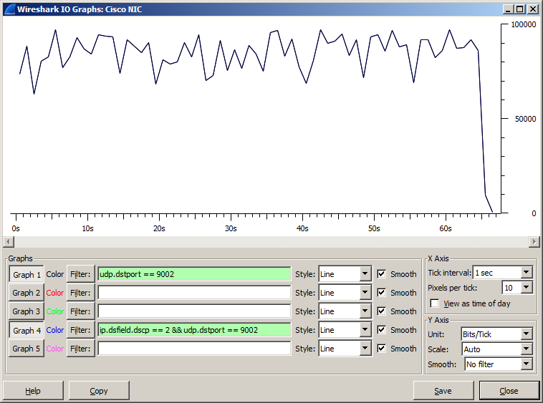

**Výpis z D-ITG:**

__________________________________________________________

**************** TOTAL RESULTS ******************

__________________________________________________________

Number of flows = 1

Total time = 64.347000 s

Total packets = 2114

Minimum delay = 344.090000 s

Maximum delay = 349.281000 s

Average delay = 347.051919 s

Average jitter = 0.027825 s

Delay standard deviation = 1.217948 s

Bytes received = 623913

Average bitrate = 77.568558 Kbit/s

Average packet rate = 32.853124 pkt/s

Packets dropped = 0 (0.00 %)

Average loss-burst size = 0 pkt

Error lines = 0

----------------------------------------------------------

**Výpis sendera:**

R1#sh policy-map int s0/0/0

Serial0/0/0

Service-policy output: SHAPING_AVERAGE

Class-map: ZAKAZNIK (match-all)

4514 packets, 1482801 bytes

5 minute offered rate 15000 bps, drop rate 0000 bps

Match: access-group 101

Queueing

queue limit 64 packets

(queue depth/total drops/no-buffer drops) 0/29/0

(pkts output/bytes output) 4485/1474043

QoS Set

dscp 2

Packets marked 4514

shape (average) cir 84000, bc 336, be 336

target shape rate 84000

Class-map: class-default (match-any)

126 packets, 8722 bytes

5 minute offered rate 0000 bps, drop rate 0000 bps

Match: any

queue limit 64 packets

(queue depth/total drops/no-buffer drops) 0/0/0

(pkts output/bytes output) 126/8722

**c.) s exp. rozdelením so strednou dĺžkou 400 B**

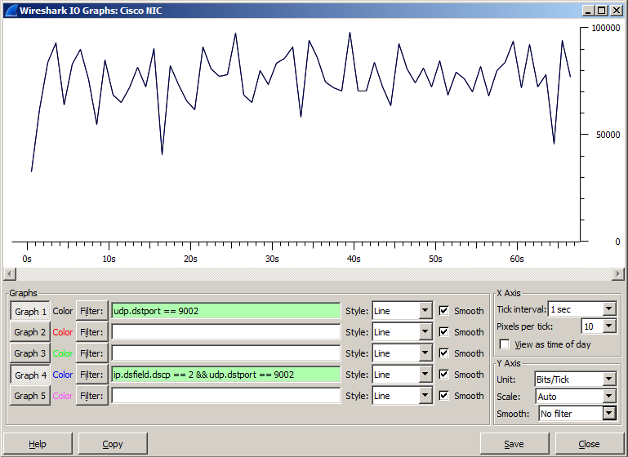

**Výpis z D-ITG:**

__________________________________________________________

**************** TOTAL RESULTS ******************

__________________________________________________________

Number of flows = 1

Total time = 63.334000 s

Total packets = 1545

Minimum delay = 344.768000 s

Maximum delay = 351.013000 s

Average delay = 348.912959 s

Average jitter = 0.039399 s

Delay standard deviation = 1.522580 s

Bytes received = 613967

Average bitrate = 77.552910 Kbit/s

Average packet rate = 24.394480 pkt/s

Packets dropped = 510 (24.82 %)

Average loss-burst size = 2.670157 pkt

Error lines = 0

----------------------------------------------------------

**Výpis sendera:**

R1#sh policy-map int s0/0/0

Serial0/0/0

Service-policy output: SHAPING_AVERAGE

Class-map: ZAKAZNIK (match-all)

6713 packets, 2421912 bytes

5 minute offered rate 25000 bps, drop rate 8000 bps

Match: access-group 101

Queueing

queue limit 64 packets

(queue depth/total drops/no-buffer drops) 0/559/0

(pkts output/bytes output) 6154/2189232

QoS Set

dscp 2

Packets marked 6713

shape (average) cir 84000, bc 336, be 336

target shape rate 84000

Class-map: class-default (match-any)

166 packets, 11543 bytes

5 minute offered rate 0000 bps, drop rate 0000 bps

Match: any

queue limit 64 packets

(queue depth/total drops/no-buffer drops) 0/0/0

(pkts output/bytes output) 166/11543

**Scenár 2. Nastavte tvarovanie prevádzky s ohľadom na špičku (shape peak)**

**a.) s rovnomerným rozdelením = uniform od 100 do 500 B**

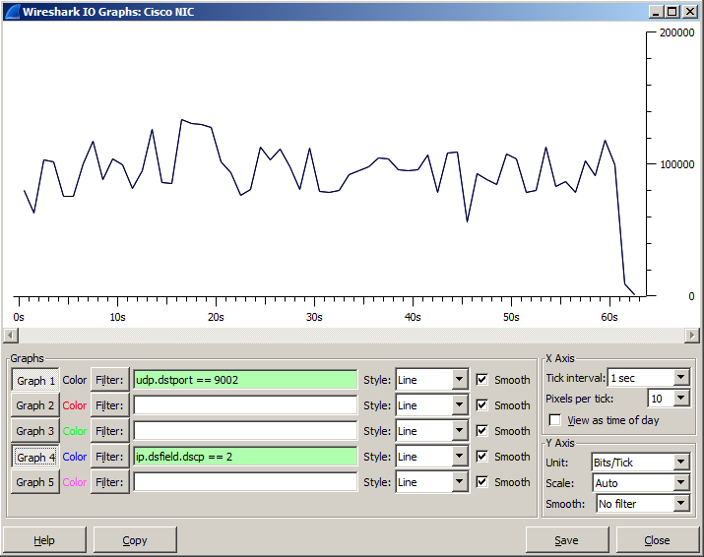

**Výpis z D-ITG:**

__________________________________________________________

**************** TOTAL RESULTS ******************

__________________________________________________________

Number of flows = 1

Total time = 61.119000 s

Total packets = 2114

Minimum delay = 427.403000 s

Maximum delay = 428.592000 s

Average delay = 428.069156 s

Average jitter = 0.013971 s

Delay standard deviation = 0.278482 s

Bytes received = 640560

Average bitrate = 83.844304 Kbit/s

Average packet rate = 34.588262 pkt/s

Packets dropped = 0 (0.00 %)

Average loss-burst size = 0 pkt

Error lines = 0

----------------------------------------------------------

**Výpis sendera:**

R1#sh policy-map int s0/0/0

Serial0/0/0

Service-policy output: SHAPING_PEAK

Class-map: ZAKAZNIK (match-all)

2114 packets, 708208 bytes

5 minute offered rate 18000 bps, drop rate 0000 bps

Match: access-group 101

Queueing

queue limit 64 packets

(queue depth/total drops/no-buffer drops) 0/0/0

(pkts output/bytes output) 2114/708208

QoS Set

dscp 2

Packets marked 2114

shape (peak) cir 84000, bc 336, be 336

target shape rate 168000

Class-map: class-default (match-any)

28 packets, 1879 bytes

5 minute offered rate 0000 bps, drop rate 0000 bps

Match: any

queue limit 64 packets

(queue depth/total drops/no-buffer drops) 0/0/0

(pkts output/bytes output) 28/1879

**b.) s exponenciálnym rozdelením so strednou veľkosťou paketu 300 B**

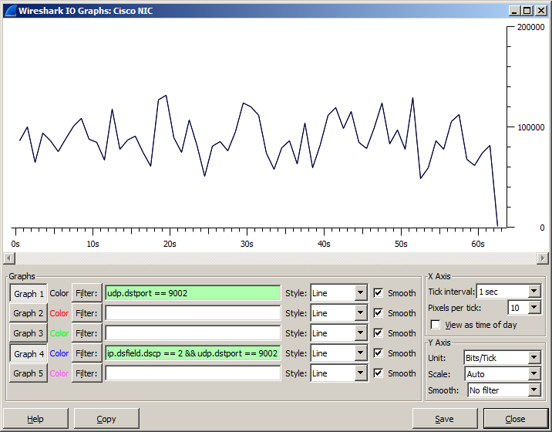

**Výpis z D-ITG:**

__________________________________________________________

**************** TOTAL RESULTS ******************

__________________________________________________________

Number of flows = 1

Total time = 61.717000 s

Total packets = 2086

Minimum delay = 335.909000 s

Maximum delay = 337.748000 s

Average delay = 336.763756 s

Average jitter = 0.019034 s

Delay standard deviation = 0.452362 s

Bytes received = 616300

Average bitrate = 79.887227 Kbit/s

Average packet rate = 33.799439 pkt/s

Packets dropped = 0 (0.00 %)

Average loss-burst size = 0 pkt

Error lines = 0

----------------------------------------------------------

**Výpis sendera:**

R1#sh policy-map int s0/0/0

Serial0/0/0

Service-policy output: SHAPING_PEAK

Class-map: ZAKAZNIK (match-all)

6314 packets, 2094269 bytes

5 minute offered rate 20000 bps, drop rate 0000 bps

Match: access-group 101

Queueing

queue limit 64 packets

(queue depth/total drops/no-buffer drops) 0/0/0

(pkts output/bytes output) 6314/2094269

QoS Set

dscp 2

Packets marked 6314

shape (peak) cir 84000, bc 336, be 336

target shape rate 168000

Class-map: class-default (match-any)

104 packets, 7098 bytes

5 minute offered rate 0000 bps, drop rate 0000 bps

Match: any

queue limit 64 packets

(queue depth/total drops/no-buffer drops) 0/0/0

(pkts output/bytes output) 104/7098

**c.) s exp. rozdelením so strednou dĺžkou 400 B**

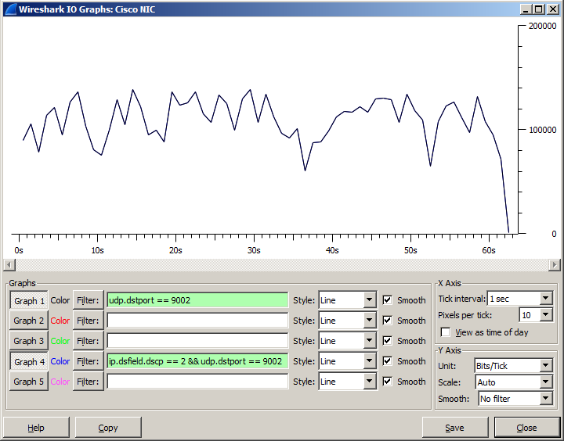

**Výpis z D-ITG:**

__________________________________________________________

**************** TOTAL RESULTS ******************

__________________________________________________________

Number of flows = 1

Total time = 61.274000 s

Total packets = 2122

Minimum delay = 347.506000 s

Maximum delay = 349.229000 s

Average delay = 348.372767 s

Average jitter = 0.025347 s

Delay standard deviation = 0.454360 s

Bytes received = 844699

Average bitrate = 110.284819 Kbit/s

Average packet rate = 34.631328 pkt/s

Packets dropped = 0 (0.00 %)

Average loss-burst size = 0 pkt

Error lines = 0

----------------------------------------------------------

**Výpis sendera:**

R1#sh policy-map int s0/0/0

Serial0/0/0

Service-policy output: SHAPING_PEAK

Class-map: ZAKAZNIK (match-all)

8510 packets, 3012935 bytes

5 minute offered rate 35000 bps, drop rate 0000 bps

Match: access-group 101

Queueing

queue limit 64 packets

(queue depth/total drops/no-buffer drops) 0/0/0

(pkts output/bytes output) 8510/3012935

QoS Set

dscp 2

Packets marked 8510

shape (peak) cir 84000, bc 336, be 336

target shape rate 168000

Class-map: class-default (match-any)

127 packets, 8530 bytes

5 minute offered rate 0000 bps, drop rate 0000 bps

Match: any

queue limit 64 packets

(queue depth/total drops/no-buffer drops) 0/0/0

(pkts output/bytes output) 127/8530